1. **CREATING DATABASE:**

DROP TABLE IF EXISTS swiggy_db;

CREATE TABLE swiggy_db (

Name VARCHAR(100),

Cuisine VARCHAR(200),

Location VARCHAR(200),

rating FLOAT,

num_of_rating INT,

price INT );

1. **OVERVIEW:**

SELECT * FROM swiggy_db;

SELECT COUNT(*) FROM swiggy_db;



1. **KPI REQUIREMENTS**:
2. Total Orders:

SELECT DISTINCT(COUNT(*)) AS total_orders

FROM swiggy_db;

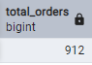

1. Average Rating:

SELECT ROUND(AVG(rating)::numeric,2 ) AS avg_rating

FROM swiggy_db;



1. Average price:

SELECT ROUND(AVG(price)::numeric, 2) AS avg_price

FROM swiggy_db;



1. Highest Rated Restaurants:

SELECT

Name,

location,

Rating

FROM swiggy_db

WHERE Rating IS NOT NULL

ORDER BY rating DESC

LIMIT 10;

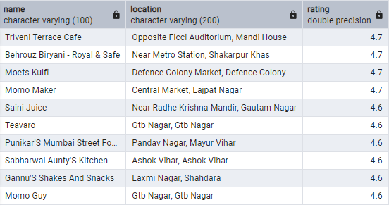

1. Most Popular Cuisines (Top 10):

SELECT

cuisine,

COUNT(*) AS total_restaurants

FROM swiggy_db

GROUP BY cuisine

ORDER BY total_restaurants DESC

LIMIT 10;

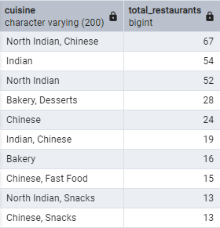

1. Affordable Restaurants (price < 500 Rs.):

SELECT

name,

location,

price

FROM swiggy_db

WHERE price < 500

ORDER BY price ASC;

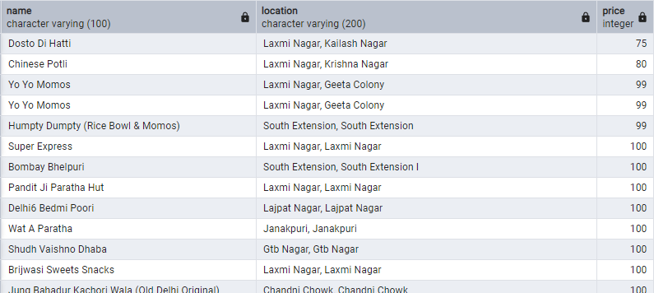

1. Average Price Per Cuisine:

SELECT

cuisine,

ROUND(AVG(price)::numeric, 2) AS avg_price

FROM swiggy_db

GROUP BY cuisine

ORDER BY avg_price;

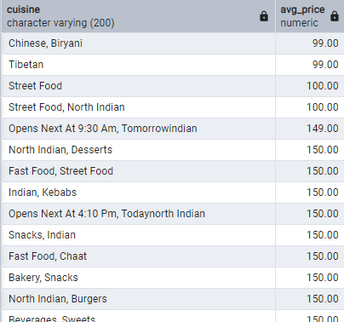

1. Location with Most Restaurants:

SELECT

location,

COUNT(*) AS total_restaurants

FROM swiggy_db

GROUP BY location

ORDER BY total_restaurants DESC;

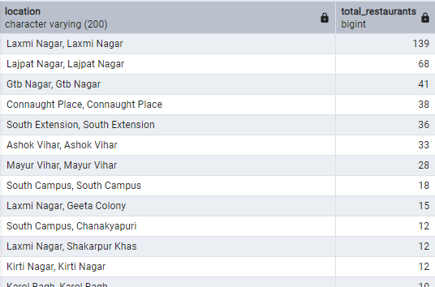

1. Whether high price restaurants rated higher?

SELECT

CASE

WHEN price < 500 THEN 'Low Budget'

WHEN price BETWEEN 500 AND 1500 THEN 'Mid-Range'

ELSE 'Luxury'

END AS price_category,

ROUND(AVG(rating)::numeric, 2) AS avg_rating

FROM swiggy_db

WHERE rating IS NOT NULL

GROUP BY price_category

ORDER BY avg_rating DESC;

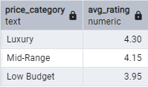

1. Cuisines with high average ratings:

SELECT

cuisine,

ROUND(AVG(rating)::numeric, 2) AS avg_rating

FROM swiggy_db

WHERE rating IS NOT NULL

GROUP BY cuisine

ORDER BY avg_rating DESC

LIMIT 10;

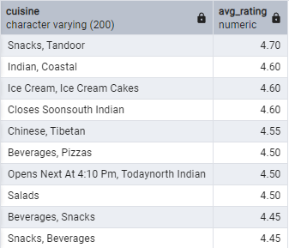

-- END OF PROJECT --